Remarks by Maine Service Employees Association, SEIU Local 1989
Before the Joint Standing Committee on Health and Human Services,
January 25, 2022

Senator Claxton, Representative Meyer, members of the Committee on Health and Human Services, I’m Jeff McCabe, director of politics and legislation for the Maine Service Employees Association, Local 1989 of the Service Employees International Union. We are a labor union representing over 13,000 Maine workers, including workers in Child Protective Services.

I am joined today by MSEA-SEIU President Dean Staffieri and MSEA-SEIU Field Representative Robin Upton-Sukeforth, who talks daily with the folks on the front line as our representative for Child Protective Services workers. We agree with much of what has been said and the reports presented today. We do feel that the Department’s numbers on recruitment and retention at times underestimate the situation regionally and statewide. Staffing shortages, staff burnout and other challenges are only made worse by the ongoing pandemic.

Key takeaways from what our members have been saying:
- Increase investment in services for children and families:
  - Increase investment and availability for in- home and foster-care behavioral health services;
  - Strengthen support for Alternative Response Programs, which assess families experiencing struggles but whose situations don’t rise to the engagement level of the Office of Child and Family Services (OCFS), with specific provisions for recruiting and retaining qualified staff;
  - Hire or contract for more Professional Supervisors for parental visits of children in foster care. If we had significantly more case aides, then they could do this work as well; case aides previously did this work.
- Ongoing training for staff and supervisors:
  - OCFS workers used to have the Child Welfare Training Institute as a resource; we should look at investing equivalent attention and resources into training today;
  - General Supervisory training.
- There’s been a lack of willingness by management to discuss Child Emergency Services issues at the bargaining table – such as management’s refusal to consider a night shift. We think a night shift should be considered.
- We’re encouraged to see coordination with others outside of Maine DHHS for community support, shared accountability in how resources are utilized, and recommendation relating to polices changes;
  - We support increased coordination; the challenge will be to ensure there is shared accountability.

In closing, we recommend taking a look at the overall state of Maine Bureau of Human Resources and ramping up its focus on the recruitment and retention of workers. The bureau should be a model for supporting workers by providing them with the tools and resources they need.

Attached you will find survey results and other information from workers. Going forward, I will serve as the contact for MSEA to answer questions and reach out to our members. I will now turn things over to Dean and Robin to share firsthand accounts from caseworkers and to answer questions. Thank you.

March 2021 Survey:
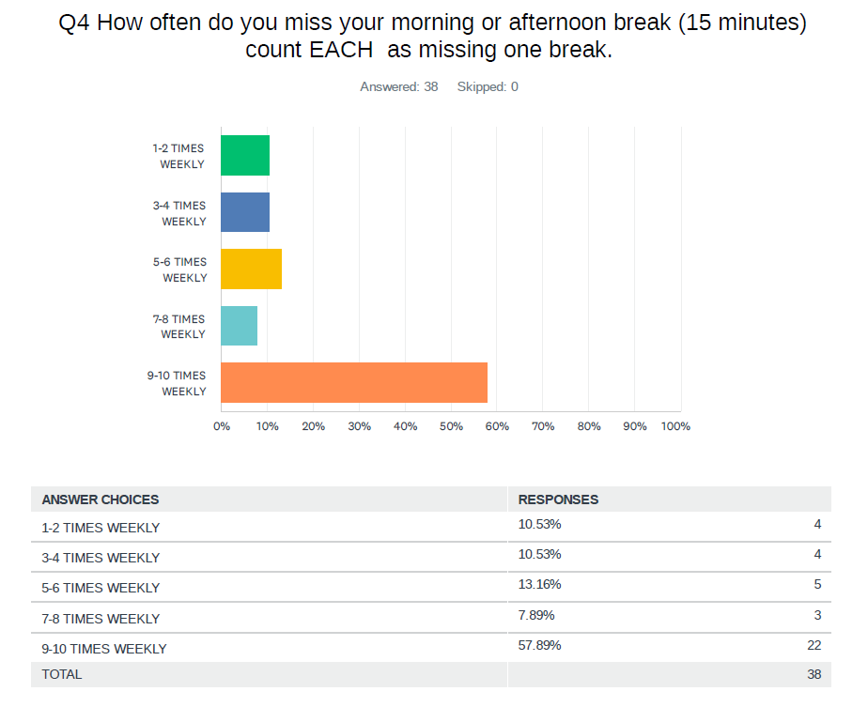
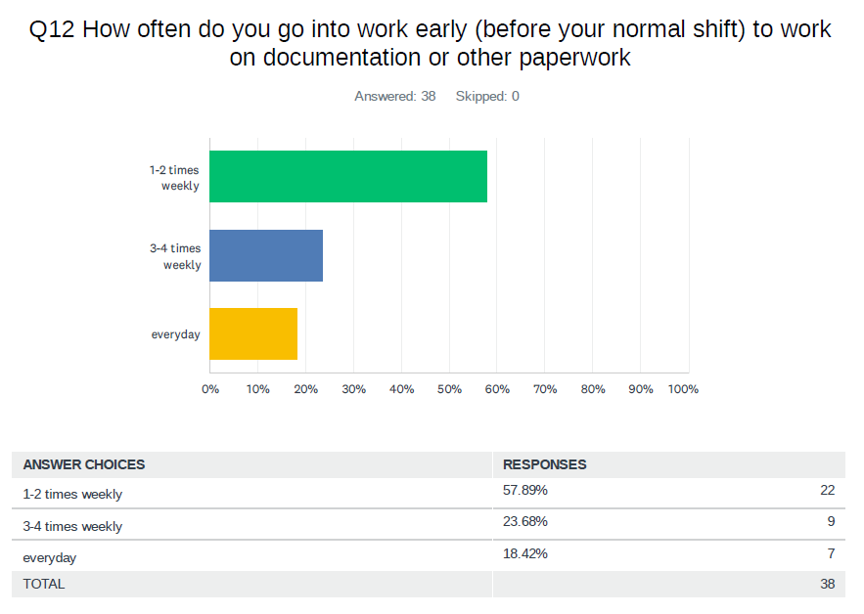
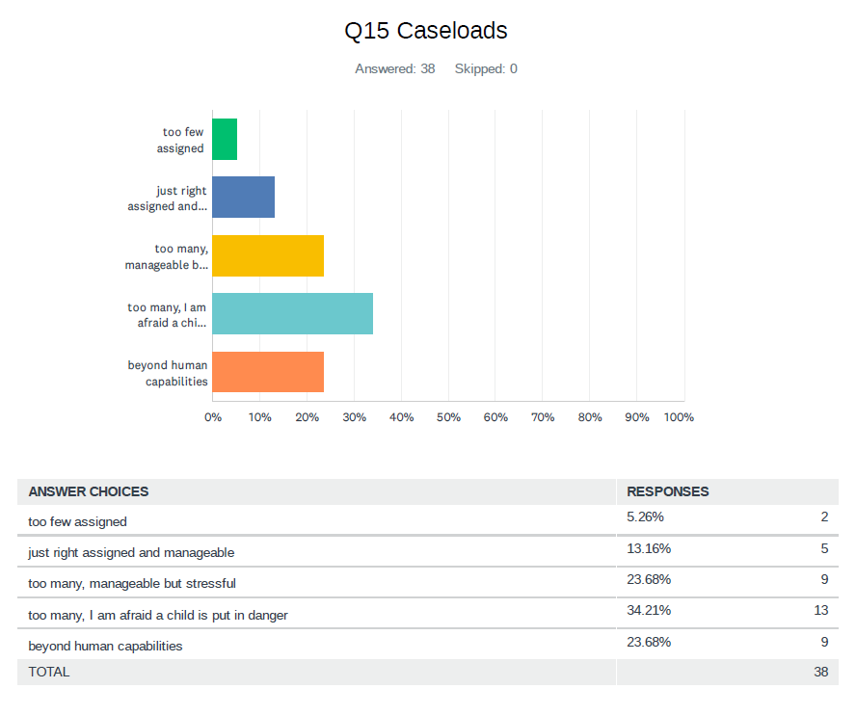
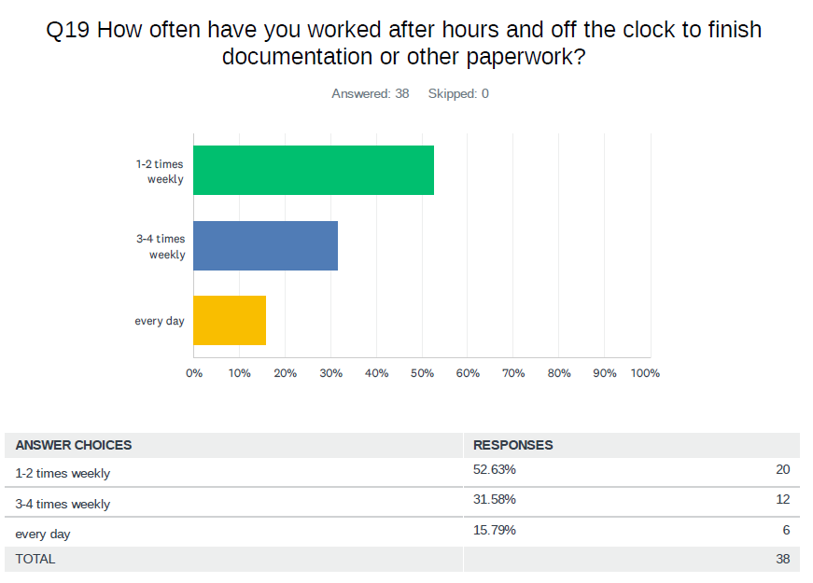

September 2021
